**St Peter’s Institute of Pharmaceutical Sciences**

**Course: Bachelor of Pharmacy**

**Subject: PATHOPHYSIOLOGY (THEORY)**

**Subject Code:** BP 204T

**Diabetes Mellitus**

Diabetes is a hetrogeneous metabolic disorder characterized by hyperglycemia with disruption in carbohydrate, fat and protein metabolism.

**Classification and Etiology:**

Diabetes id two types

1. Type-I Diabetes Mellitus

2. Type-II Diabetes Mellitus

3. Gestational Diabetes Mellitus

**Type-I Diabetes Mellitus**

Previously, it is also called as insulin dependent or juvenile-onset diabetes. 10% cases are Type-I Diabetes Mellitus.

Newer classification: 1. Type-IA DM

2. Type-IB DM

**Type-IA DM**: immune mediated which is characterized by autoimmune destruction of β-cells leads to insulin deficiency.

**Type-IB DM:** Idiopathicwhich is characterized by insulin deficiency and develops ketoacidosis. Not related to autoimmune disorder.

**Type-II Diabetes Mellitus**

Earlier it is called as non-insulin dependent diabetes mellitus, or maturity-onset diabetes. 80% cases are due to Type-II Diabetes Mellitus. It affects older people and obese adolescent children.

**Other types:**

1. Genetic defects of β-cells function
2. Genetic defects in insulin action
3. Disease of exocrine pancrease
4. Endocrinopathies: eg. cushing’s syndrome
5. Drug or chemical induced: eg. steroids
6. Infections. eg: congenital rubella
7. Uncommon forms of immune mediated DM: eg. Stiff man syndrome
8. Other genetic sydromes: eg. Down’s syndrome

**Gestational Diabetes Syndrome**

4% women develop diabetes during pregnancy due to metabolic changes. After delivery it becomes normal. They have more risk to develop diabetes in later stages.

**Pathogenesis**

**Normal insulin metabolism:**

**Synthesis:** synthesised in β-cells of pancreatic islets of Langerhans. Pre-proinsulin which is single chain 86-amino acid precursor polypeptide undergoes proteolysis and forms proinsulin. Proinsulin undergoes cleavage and gives rise A(21 amino acids) and B(30 amino acids) chains. These chains are connected with C-peptide.

**Release:** Glucose plays key role in insulin secretion from β-cells. Hypoglycaemia (glucose levels <70mg/dl or <3.9 mmol/L) stimulates insulin release through GLUT2 transporter. Others also include ketones, amino acids and nutrients in meals. Metabolism of glucose to glucose-6-phosphate by glycolysis generated ATP. This ATP inhibits ATP sensitive potassium channel and opens calcium channels leads to influx of calcium ultimately stimulates the release of insulin.

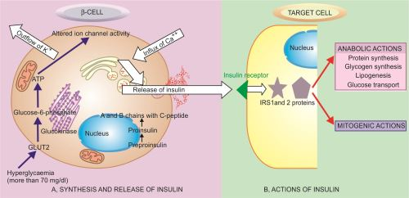

A pathway of normal insulin synthesis and release in β-cells of pancreatic islets, chain of events in action of insulinof target cells. **Ref: textbook of pathology Harsh mohan**

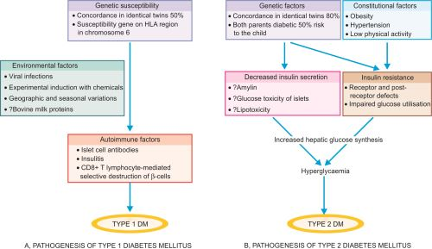

Schematic mechanism involved in pathogenesis of two main types of DM. **Ref: textbook of pathology Harsh mohan**

**Clinical Features**

**Type-I DM:** Polyuria, Polydipsia, polyphagia, loss of weight, ketoacidosis, and hypoglycaemic episodes.

**Type-II DM:** weakness, loss of weight, Polyuria, and polydipsia. Ketoacidosis is infrequent.

**Complications**

Diabetic ketoacidosis

Atherosclerosis

Coma

Hypoglycaemia

Diabetic nephropathy

Diabetic retinopathy

**Diagnosis:** urinetest**,** oral glucose tolerance test, and HbA1c .

**References:**

1. Vinay Kumar, Abul K. Abas, Jon C. Aster; Robbins &Cotran. (2014) Pathologic Basis of Disease; South Asia edition; India; Elsevier.
2. Harsh Mohan; Text book of Pathology; 6 th edition; India; Jaypee Publications; 2010.
3. Laurence B, Bruce C, Bjorn K. ; Goodman Gilman’s (2011). The Pharmacological Basis of Therapeutics; 12 th edition; New York; McGraw-Hill;
4. Nicki R. Colledge, Brian R. Walker, Stuart H. Ralston; Davidson’s Principles and Practice of Medicine; 21st edition; London; ELBS/Churchill Livingstone; 2010.